Figure 1
Simple Slopes Illustrating the Moderating Effect of Chronotype on the Relationship Between Depressive Symptoms and Bedtime Procrastination
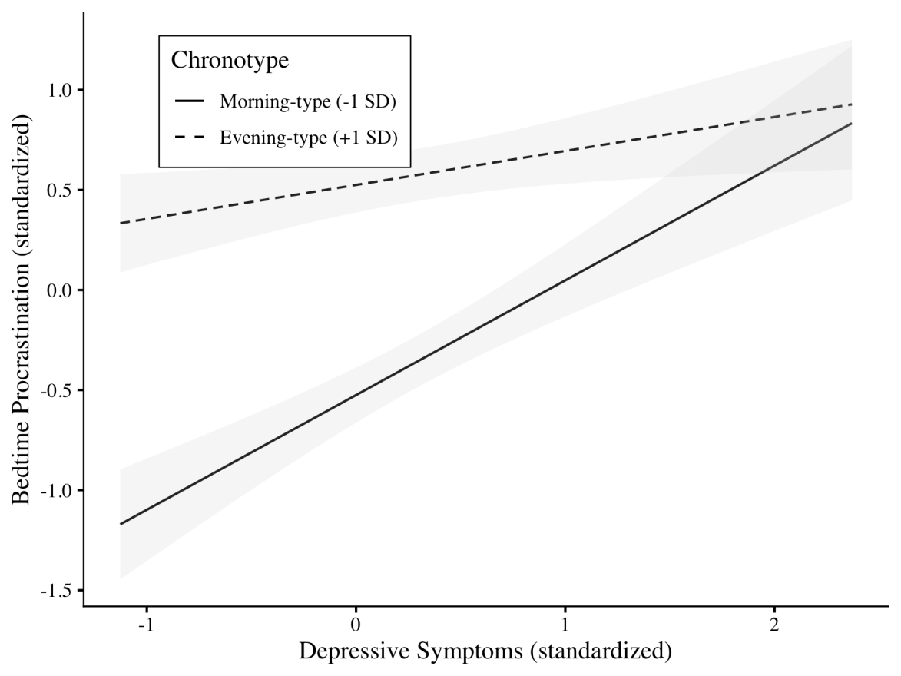
Note. Depressive symptoms and bedtime procrastination scores are standardized. Chronotype was measured using the reduced Morningness-Eveningness Questionnaire, with higher scores indicating greater eveningness. Shaded areas represent 95% confidence intervals.

